MẠNG MÁY TÍNH 2024-2025
Quarter 4
Section 1 (60 marks)
Question 1: Which layer of the OSI model does a Switch device typically reside at?
A. Physical layer
B. Data-link layer
C. Network layer
D. None of these
Question 2: Which layer of the OSI model does IP protocol work at?
A. Network layer
B. Datalink layer
C. Physical layer
D. Transport layer
Question 3: Given the binary version of an IP as follow: 10101100.00010000.00000010.10100000
What is the decimal version of this IP?
A. 172.16.0.0|
B. 172.16.2.0
C. 172.0.1.0
D. 172.16.1.0
Question 4: Which one of the following is NOT a network topology?
A. Star
B. Bus
C. Ring
D. Sphere
Question 5: What is the prefix length notation for the subnet mask 255.255.240.0?
A. /20
B. /21
C. /19
D. /18
Question 6: What is the subnet mask of the network 10.10.114.0/12?
A. 255.254.0.0
B. 255.224.0.0
C. 255.252.0.0|
D. 255.240.0.0
Question 7: Which of the following best describes the Client/Server network architecture?
A. A network where all devices are connected directly to each other without a central server.
B. A network where a central server provides resources and services to multiple client devices.
C. A network where each device performs both client and server roles equally.
D. A network that uses only wireless connections to communicate between devices.
Question 8: What is the default subnet mask for Class B IP address?
A. 255.255.0.0
B. 255.255.255.0|
C. 255.0.0.0
D. 255.255.255.255
Question 9: What is port number of HTTPS protocol?
A. 80
B. 221
C. 443
D. 21
Question 10: What is the private IP range for Class B?
A. 172.16.0.0 to 172.31.255.255
B. 10.0.0.0 to 10.0.255.255
C. 192.168.0.0 to 192.168.255.255
D. 0.0.0.0 to 0.0.0.255
Question 11: What is a network protocol?
A. A hardware device used to connect different networks
B. A set of rules and conventions for communication between network devices
C. A software application used for browsing the Internet
D. A type of computer network security measure
Question 12: Which protocol operates on port 53 and is used for translating domain names to IP addresses?
A. DHCP
B. TCP
C. DNS
D. UDP
Question 13: What is the port number for FTP protocol?
A. 20
B. 221
C. 22
D. 21
Question 14: What is the name of the missing layer in the image below?
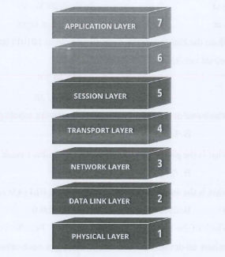
A. Presentation layer
B. Internet layer
C. Access layer
D. None of these
Question 15: Which device is typically responsible for managing network traffic and providing internet access to other devices?
A. Switch
B. Hub
C. Router
D. All of them
Question 16: What does the word LAN stand for?
A. Local Array Net
C. Local Area Node
B. Local Area Network
D. Local Array Node
Question 17: Which of the following IP addresses belongs to class A?
A. 121.12.12.248
B. 128.12.12.248
C. 129.12.12.248
D. 130.12.12.248
Question 18: What is the public IP range for Class A?
A. 10.0.0.0 to 10.255.255.255
C. 128.0.0.0 to 191.255.0.0
B. 1.0.0.0 to 127.0.0.0
D. 172.16.0.0 to 172.31.255.255
Question 19: What is the command generated the output shown in the figure below?
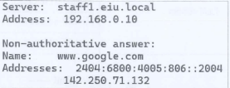
A. ping
B. route
C. netstat
D. nslookup
Question 20: Assume that we have the network 200.10.0.0/24 and we want to divide it into 4 subnets.
What is the last IP address of the 1st subnet?
A. 200.10.0.126
B. 200.10.0.127
C. 200.10.0.62
D. 200.10.0.63

Section 2 (40 marks)
Question 1: A given network address: 205.11.2.0/24. Divide the above network into 16 subnets and fill in the table below (20 marks)
